<https://appbrewery.github.io/grid-vs-flexbox/>

Remember, when you create a grid, all items inside that container become a grid-item, (previously paragraph, h1, images etc)

Auto on columns, fit to screen, while on rows, takes only space needed to fit all content, lets say black one is browser window.

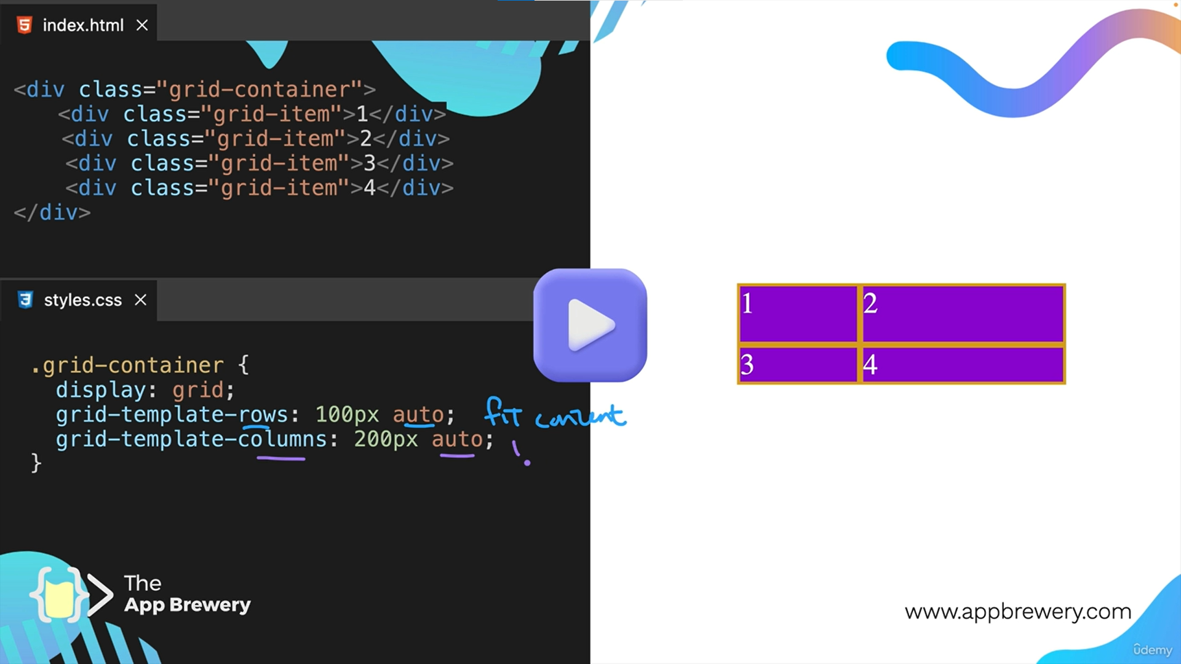

Except when it is inside a container and container height is defined, in this case it would stretch full towards end.

<https://appbrewery.github.io/grid-sizing/>

tracks in grid means rows and columns

<https://appbrewery.github.io/gridgarden/> 🡨 game to understand grid positioning better